Meta Description:
Keyword difficulty tells us about how hard it is for a specific keyword to rank on the first pages of Google. Read this guide to dominate search results.

Title: Keyword Difficulty Decoded: A 3D Framework to Master SEO Competition & Dominate Search

Keyword Difficulty Decoded: A 3D Framework to Master SEO Competition & Dominate Search
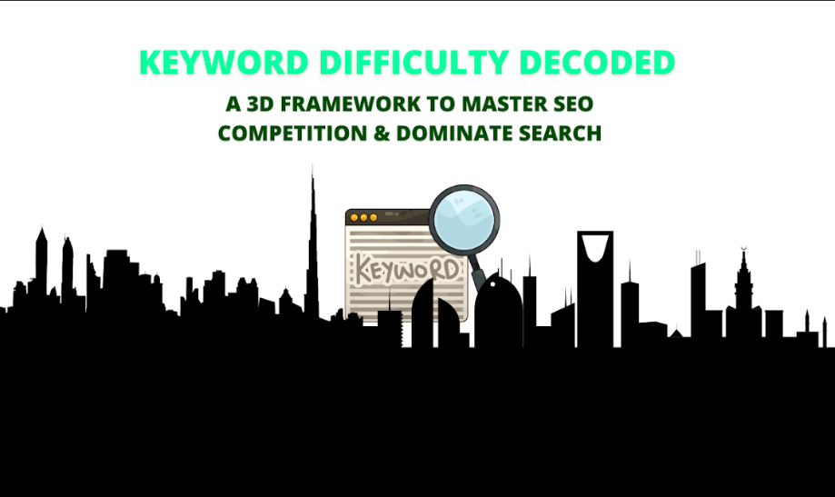
SEO competition in the digital world is often referred to as a complex game of Chess.
Over the years, different techniques that are applied to gain control of various search engine result pages (SERPs) have also changed.
This battle is primarily waged on the grounds of keyword difficulty.
However, indicators as previously defined are often misleading because they do not take into account certain factors that greatly influence SE rankings.
Here in this guide, we have developed, what we consider, a perfect keyword difficulty measurement that also gives you a map to leave your competitors in the dust.

What is Keyword Difficulty?
Keyword difficulty tells us how hard it is to rank on the first pages of Google based on a particular keyword.
The process of optimizing a website has been known for years as the tricky and competitive race for the top position on the Search Engine Results Page (SERP).
In the world of SEO, no keyword is trivial. Every keyword is a fight to the finish at the top.
The fight for SERP position is a silent battle that may not always be comprehensively described by average ranking data or indicators.
Keyword difficulty has been at the heart of SEO for several years, but now it is often misconceived.
Almost all SEO-related programs provide a single figure, a score, which is to suggest the feasibility of ranking for some term in the Internet search.
But such scores do not always reflect the scenarios that characterize modern-day SEO.
Traditional keyword difficulty scores do not consider a range of aspects that are relevant in the case of ranking.
A single score may provide you with an estimate of the difficulty of targeting particular keywords in terms of backlinks and domain ones, but it neglects other factors such as SERP features, content quality, etc.
These areas are not addressed by the current methods. That’s where our 3D framework can help provide a better insight into the value and potential of keyword difficulty.

Beyond Metrics: A New Approach to Keyword Difficulty
Actual keyword difficulty scores are less effective in the modern context of SEO because they were developed based on historical data and using the algorithms that do not map the real-time processes.
These metrics could be used as starting points, but they are normally not enough to fully assess the positioning.
Our 3D framework does not limit to the above-mentioned aspects but includes other dimensional layers to analyze.
- SERP Features: Understand how other SERP features that may take up a significant part of the first page of the result, such as the featured snippets, videos, shopping carousels, etc.
- Content freshness: Look for situations where high-ranking websites publish low-quality content that can be attacked.
- Intent and Entities: Find out how intent of the search query and the so-called ‘entities’, or other reputable sources of information, affect keyword difficulty.
By combining these dimensions, our framework offers a better perspective on keyword difficulty so one can make better decisions.

The Evolution of Keyword Difficulty: From Guesswork to AI:
Forcing inception into the concept of Keyword Difficulty metric can be marked for good.
Generally, it has been a long and ever aging process.
Five to ten years ago, keyword difficulty could be defined as simplistic factors such as the corresponding metatag spam as well as the keyword density.
With the advancement of search engines, it is possible now to see that many other factors of keywords became relevant in ascertaining the keyword difficulty.
By 2025, advancements in artificial intelligence have completely changed the approach to analyzing the keyword difficulty.

The Black Box Problem:
Most SEO tools have their unique algorithm for measuring keyword difficulty scores and for this reason, one tool may bring a totally different score to another.
While each software like Ahrefs, SEMrush, and SpyFu has its working algorithm, it becomes difficult to cross-check outcomes.
This “black box” problem signifies that SEO specialists often have to select which tool can be trusted while it is unclear what formulas have been used.

The Rise of “Intent Difficulty”:
Another major change in the determination of keywords’ difficulty level is the “intentional difficulty.”
Intent difficulty differs from other approaches that hugely rely on backlinks and the domain authority of the website.
This shift incorporates the notion that behavioral patterns of users have become much more important to SEO than before.
Additionally, it becomes more evident that keywords that are highly synced with the user intent can rank high even when they hold little or no backlinks.

The Anatomy of Keyword Difficulty: Breaking Down the Beast

The 4 Hidden Pillars Most Tools Ignore:
It is important to disentangle the concept of keyword difficulty into its constitutive parts. This is exactly why our 3D framework deconstructs keyword difficulty based on four hidden factors that most tools do not consider.
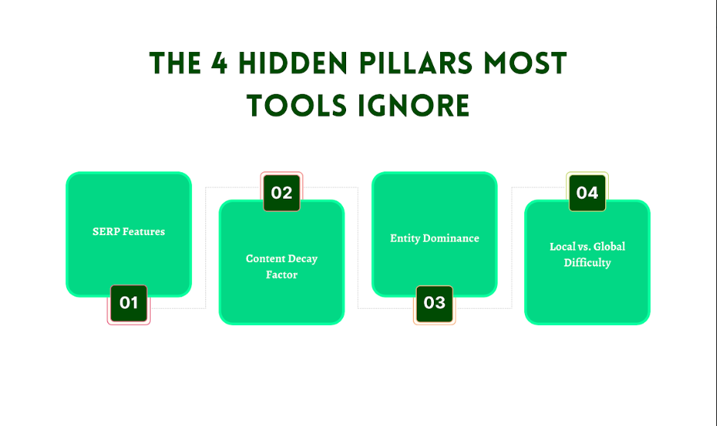

SERP Features:
It is clear that SERP features like the featured snippets, videos, and shopping carousels have great influence on the possibility of ranking for a particular keyword.
These features are commonly located in the most visible positions of the SERP, depriving traditional textual content of good visibility.
These features are worthy of understanding as well as deserving targets to gain a competitive edge.

Content Decay Factor:
This means that the content previously used when searching for information on a particular topic can be overtaken soon after it appears at the top of the rankings.
This naturally leads to the emergence of new, original and valuable content to the top of the SERP.
It is crucial that when the keywords are identified, the contents are likely to fade out as it is a valuable tool for SEO.

Entity Dominance:
Generally, the information that is associated with certain words is controlled by the BIG brands and authoritative sources. Most of the time, when a prestigious brand name like Forbes or Wikipedia is branding a particular keyword, one can be greatly boxed into a corner to struggle for the same. Instead, it is better to look for variations of the keyword or specific aspects of it with higher commercial intent.

Local vs. Global Difficulty:
Keywords can be very different depending on the location. The term such as “Best Digital Agency” can be easier to optimize for in a specific geographical location such as in Dubai than in a wider area such as the UAE.
It can be seen that the SEO strategy differs depending on certain local conditions.

The Myth of Domain Authority:
Most of the SEO experts have adopted Domain Rating (DR) or Domain Authority (DA) as the measure of keyword difficulty.
However, these metrics do not work or do not give a full picture of the equation.
A site with low DR or DA can easily compete with a site that has good DR or DA if the factor of the competitor site is bad in other aspects, such as content quality or usability.
For instance, highly relevant and high-quality content of DR 20 ranking can easily overcome a site of DR 80 if it contains irrelevant or low-quality content.

How to Measure Keyword Difficulty Like a Forensic Analyst?

The Toolbox Breakdown:
Our prepared toolbox is divided into three major categories, such as automated scores, manual audits, and SERP autopsy methods. Let’s have a look at each category step by step:

Automated Scores:

- Ahrefs: It has been considered to be the most powerful tool due to its big and reliable keyword database and the reasonable estimation of the keyword difficulty. Nonetheless, it lacks transparency as sometimes it relies on secret algorithms to arrive at the set scores.
- SEMrush: Has a wide range of options, including Kd values that make use of search traffic and historical and current data.
- Mangools: Has a simple user interface to keyword metrics and is compatible with other SEO tools. However, it can provide fewer specific results than both Ahrefs and SEMrush. Moreover, it is not dependable when it comes to niche keywords.

Manual Audits: A Step by Step Guide
Anyone who is not afraid of manually sorting and compiling data will find it incredibly useful to use it.
Here are the steps to help you determine keyword difficulty in a basic manner, without any tools, with the help of Chrome extension:

- Extensions: Some of the extensions that can be used include Keywords Everywhere, and MozBar.
- Analyze Top 10 Results: Search the web to determine the domain authority of each of the results and the page authority.
- Average Scores: It would be important to establish the average authority required to rank.
- Assess Backlink Profiles: It is recommended to type the keyword in Ubersuggest to check backlink profiles of the competitors’ websites.
- Assess the number and the quality of the content: It is recommended to make a manual check of their length and depth by using tools for readability.

The “SERP Autopsy” Method:
Through SERP autopsy, you can analyze a strategy of reverse engineering on the first 10 rankings to find out and expose gaps in the competitor strategies.

- Syllabus Gaps: Determine any format of the content that is missing in the syllabi (e.g., no videos sharing or no infographics).
- Measures of Fact: Determine how closely you were able to cover the facts in your results.
- Analyze Backlinks: A good number of websites should be linked to many other sources as they are an indicator of the visibility of the site in the online community.
- Spot Technical Issues: The current technical problems can be detected by using the MobileFriendly Test and PageSpeed Insights of Google.

The Three Angle Marketing Formula:
Let’s have a proper understanding about the Three Angle Marketing formula to calculate keyword difficulty through diverse ways:

Technical Score:
- Speed: Bear in mind that the speed of your site has a significant influence on the metrics. So, make sure your site speed is fast to avoid penalties and influence the experience of the audience positively.
- Schema: Use schema to improve your exposure in the search results.
- MobileFriendly: There is a great potential of traffic from mobile devices, optimize for both tablets and mobile phones.

Strategic Score:
- Quality: Produce content of good depth and ensure the articles offer comprehensive answers to the users’ queries.
- Backlink Velocity: Aim to have a healthy number of backlinks that are from high authority sites and should be obtained consistently.
- Social Signals: Social Media can be employed for increasing people engagement and traffic.

Psychological Score:
- Relevance: Make sure that all the content corresponds to the user intention for your target niche.
- Emotional Triggers: Consider using emotional triggers within the content to make the readers stay on the site longer.

The Dark Side of Keyword Difficulty: Traps, Myths & Biases

The “Low-Hanging Fruit” Fallacy:
Many SEO experts always go for easy terms in the belief they will reap huge benefits. It is common to find some keywords that are devoid of any traffic altogether because there is competition and very little search for such categories.
Generally, keywords should be of moderate competitive level, which means they should not be very competitive, but they should not be quite popular either.

Tool Bias Alert:
Keyword difficulty is sometimes inflated to make people switch to paid options. It is advisable to compare score totals with other forms of audits and tools to obtain a more accurate picture.

The Cannibalization Curse:
It is also important not to target similar keywords as two or more pages might be targeting the same keywords and effectively compete against each other, ultimately reducing their effectiveness.
With regards to this matter, it is advisable to utilize canonical tags and internal linking.

Advanced Tactics to Hack Keyword Difficulty:
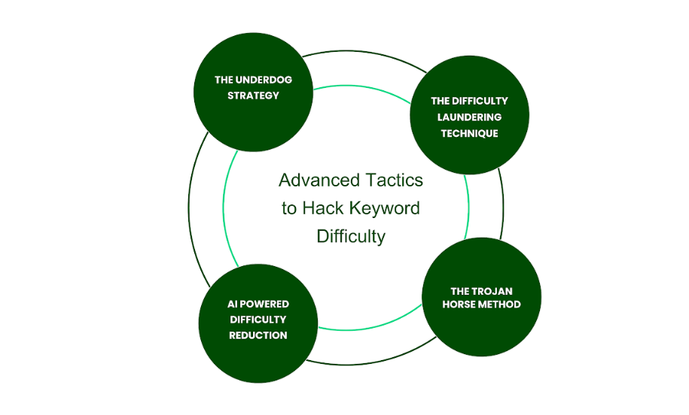

The Underdog Strategy:

SERP Gap Exploitation
Exploit all available mediums that other mediums of your competitors have not adopted in their marketing efforts, such as videos or infographics, and the business should fill these gaps.

Zombie Keywords
Revive old broken terms by applying the trending factor or modifying them and including new themes that are appealing to the users.

The Trojan Horse Method:
It is very important to create longform content in an effort to ride on the high difficulty short keywords. By giving complete details, you can get high specific searches and rank for synonyms as well.

AI Powered Difficulty Reduction:
We advise you to use external tools, such as Clearscope and SurferSEO to make your content more optimal and minimize the keyword difficulty score. These tools can be useful in helping you to achieve the correlation with the top-ranking pages, ultimately enhancing your chances of ranking.

The Difficulty Laundering Technique:
Involve influencers or media outlet platforms to obtain backlinks and increase the domain authority of your website. With this technique, it becomes easier to reduce the perception of difficulty in targeting high competition keywords.

Keyword Difficulty Beyond Google: The Uncharted Frontiers

YouTube & TikTok:

Generally, the importance of video content has increased, and tools such as YouTube and TikTok have become very important for the specific keywords.
As we know, keywords on YouTube are not only the titles, descriptions, tags, and links to Web resources, but they also include the words that are inserted in the body of the video and the words that are actually spoken in the course of the video.
Taking into account the rivals, it is necessary to consider the video length, number of likes, comments, shares, and drop-off rate.
TikTok is famous due to its algorithm-driven discovery, demands creativity, and trendiness. Here, the keyword difficulty depends on the hashtag, the popularity of the content, and the interaction ratio of a content creator.

Amazon & Etsy:

Ecommerce platforms like Amazon and Etsy present unique challenges.
Indeed, on Amazon, keywords can be placed in the title, description, bullets, and backend keywords sections.
Here competition is high, keyword density depends on the number of similar products, the average of their sales rank, and the reviews.
Every specific niche marketplace like Etsy needs to know about longtail keywords and specific product descriptions because the competition is relatively higher there.
In these platforms, effectiveness means getting proper exposure whilst maintaining traffic relevance and using the customer data to fine tune the keywords.

B2B Queries on LinkedIn:

LinkedIn is the leading source of professional interactions with the purpose of business selling.
That’s why gaining insight into the specific keyword difficulty best suited for the platform is essential. Here, keywords are within profile titles, posts, articles and the group discussions section.
This competition has been occasioned by the levels of industry authority, the network size, and the engagement levels that are recorded by the players out in the market.
Specifically, for the case of B2B, there are important considerations to be taken when it comes to keyword search queries. So, make sure you select the keywords that are appealing to the decision maker and other key opinion leaders.
Therefore, the analysis of competitors’ engagement as well as the types of their contents posted can help in understanding suitable keywords to be used.

Future Proofing Against Difficulty Shifts:

AI’s Double-Edged Sword:
AI is an influential technology that is revolutionizing SEO in a bid to deliver different values and risks.
On one hand, AI can expand keyword research with the help of such techniques as analytics and predictive modeling.
On the other hand, it can increase the volatility of keyword difficulty based on the changes in algorithms.
To always remain at the top, it is crucial to be always on the lookout for changes, update keyword lists, try out new AI-based tools for the same, or learn more about changes in the algorithms.

Voice Search Complexity:
Voice search is another element that adds depth to the concept of keyword difficulty.
As a voice assistant, products such as Siri, Alexa, and Google Assistant become more popular for longtail and conversational keywords.
These types of queries are usually in natural language, and it means a transition from keyword-based optimization to those written like a conversation.
Using voice search, you should be able to track changes in the difficulty level of certain keywords.

The Zero Click Apocalypse:
SERPs provoke the “zero click apocalypse” due to the absence of necessity to click through to a website.
This shift affects keyword difficulty because the content is selected based on how closely it answers the queries.
For the future forward approach, it is crucial to produce vast and valuable content that aligns with user search intent. Moreover, you can also rely on the promotion of schema markup for improved rich snippet appearance.

The Three Angle Marketing Action Plan:
Three Angle Marketing (TAM) is a leading Digital Marketing Agency in Dubai, which has expertise in SEO and keyword handling. Check out our action plan that can help you get better results in terms of keyword ranking in no time.

The Difficulty Decision Matrix:
It is possible to assign nonstandard keyword difficulty values; at TAM we like to be very orderly when it comes to this subject.
Our Difficulty Decision Matrix allows us to assess the specific keywords with regards to the competition. Additionally, it also helps us to understand the relevance of the topic for your blog or website.
This analysis process will enable us to identify keywords that can be effectively targeted based on the invested efforts.

DIY Keyword Difficulty Workbook:
To be more helpful for our clients, we made available a DIY Keyword Difficulty Workbook.
This Workbook provides step-by-step instructions on how to find, evaluate, and incorporate keywords in different platforms.
It also provides sample structures, notions, and examples for using our 3D framework efficiently.

Tool Stack Recommendations:
It is essential to note that the right tool that is suitable for any SEO strategy is a mandatory tool that cannot be overlooked.
To aid you to deal with keyword difficulty, we suggest following the following tool stack:

- SEMrush & Ahrefs: For comprehensive keyword research and competitive analysis.
- Moz Pro: For keyword difficulty scoring and domain authority insights.
- TubeBuddy & VidIQ: For YouTube-specific keyword optimization.
- Amazon SEO Tools & Plink.io: For Amazon product optimization.
- EtsyRank & SurferSEO: For Etsy store and content optimization.
- LinkedIn Sales Navigator: For B2B keyword strategy on LinkedIn.

Conclusion:
By knowing about factors that make certain keywords difficult, you can gain insights about trends in the market. Moreover, this also provides info on the actions of the competitors and behavior of the target audience. This makes difficulty not a challenge to overcome, but a plan to be followed on the way to leadership.
Altogether, keyword difficulty is not a simple mechanism that can be dealt with solely from the SEO perspective. With the help of our 3D framework, the topic of SEO competition will no longer be puzzling to you. By following this framework, you can manage to take first or second place in cross-platform SEO results. At TAM, we assist in every stage of its development and consider change as a way of improvement. Welcome to TAM where you can realize the potential of your digital marketing venture.

